Chapter 08
Stock Valuation

Multiple Choice Questions
1. What is the model called that determines the present value of a stock based on its next annual dividend, the dividend growth rate, and the applicable discount rate?
A. zero growth
B. dividend growth
C. capital pricing
D. earnings capitalization
E. discounted dividend

2. Which one of the following is computed by dividing next year's annual dividend by the current stock price?
A. yield to maturity
B. total yield
C. dividend yield
D. capital gains yield
E. growth rate

3. Which one of following is the rate at which a stock's price is expected to appreciate?
A. current yield
B. total return
C. dividend yield
D. capital gains yield
E. coupon rate

4. Which one of the following types of stock is defined by the fact that it receives no preferential treatment in respect to either dividends or bankruptcy proceedings?
A. dual class
B. cumulative
C. non-cumulative
D. preferred
E. common

5. A company has two open seats, Seat A and Seat B, on its board of directors. There are 6 candidates vying for these 2 positions. There will be a single election to determine the winner of both open seats. As the owner of 100 shares of stock, you will receive one vote per share for each open seat. You decide to cast all 200 of your votes for a single candidate. What is this type of voting called?
A. democratic
B. cumulative
C. straight
D. deferred
E. proxy

6. You want to be on the board of directors of Wisely Foods. Since you are the only shareholder that will vote for you, you will need to own more than half of the outstanding shares of stock if you are to be elected to the board. What is the type of voting called that requires this level of stock ownership to be successfully elected under these conditions?
A. democratic
B. cumulative
C. straight
D. deferred
E. proxy

7. You cannot attend the shareholder's meeting for Alpha United so you authorize another shareholder to vote on your behalf. What is the granting of this authority called?
A. altering
B. cumulative voting
C. straight voting
D. indenture agreement
E. voting by proxy

8. What are the distributions to shareholders by a corporation called?
A. retained earnings
B. net income
C. dividends
D. capital payments
E. diluted profits

9. Which one of the following is a type of equity security that has a fixed dividend and a priority status over other equity securities?
A. senior bond
B. debenture
C. warrant
D. common stock
E. preferred stock

10. Callander Enterprises stock is listed on NASDAQ. The firm is planning to issue some new equity shares for sale to the general public. This sale will occur in which one of the following markets?
A. private
B. auction
C. exchange floor
D. secondary
E. primary

11. The secondary market is best defined by which one of the following?
A. market in which subordinated shares are issued and resold
B. market conducted solely by brokers
C. market dominated by dealers
D. market where outstanding shares of stock are resold
E. market where warrants are offered and sold

12. An agent who maintains an inventory from which he or she buys and sells securities is called a:
A. broker.
B. trader.
C. capitalist.
D. principal.
E. dealer.

13. An agent who arranges a transaction between a buyer and a seller of equity securities is called a:
A. broker.
B. floor trader.
C. capitalist.
D. principal.
E. dealer.

14. The owner of one of the 1,366 trading licenses for the NYSE is called a:
A. broker.
B. member.
C. agent.
D. specialist.
E. dealer.

15. The person on the floor of the NYSE who executes buy and sell orders on behalf of customers is called a(n):
A. floor trader.
B. dealer.
C. specialist.
D. executor.
E. commission broker.

16. A market maker who acts as a dealer in one or more securities on the floor of the NYSE is called a:
A. floor trader.
B. floor post.
C. specialist.
D. floor broker.
E. commission broker.

17. A floor broker on the NYSE does which one of the following?
A. supervises the commission brokers for a financial firm
B. trades for his or her personal inventory
C. executes orders on behalf of a commission broker
D. maintains an inventory and takes the role of a specialist
E. is charged with maintaining a liquid, orderly market

18. An individual on the floor of the NYSE who owns a trading license and buys and sells for his or her personal account is called a:
A. floor trader.
B. exchange customer.
C. specialist.
D. floor broker.
E. market maker.

19. Which one of the following is the electronic system used by the NYSE for directly transmitting orders to specialists?
A. OTCDOT
B. SuperDOT
C. Instinet
D. Internet
E. Floornet

20. The stream of customer orders coming in to the NYSE trading floor is called the:
A. paper trail.
B. trading volume.
C. order flow.
D. bid-ask spread.
E. commission trail.

21. The counter area on the floor of the NYSE where a specialist operates is called a:
A. pit.
B. hot spot.
C. seat.
D. post.
E. DOT.

22. A securities market primarily comprised of dealers who buy and sell for their own inventories is referred to which type of market?
A. auction
B. private
C. over-the-counter
D. regional
E. electronic network

23. An ECN is best described as:
A. an electronic network which transmits orders directly to the floor of the NYSE.
B. the network used in the primary market for selling newly issued shares.
C. the international trading network of the NYSE.
D. a website that allows individual investors to trade directly with one another.
E. a computerized network used by independent brokers.

24. National Trucking has paid an annual dividend of $1.00 per share on its common stock for the past fifteen years and is expected to continue paying a dollar a share long into the future. Given this, one share of the firm's stock is:
A. basically worthless as it offers no growth potential.
B. equal in value to the present value of $1 paid one year from today.
C. priced the same as a $1 perpetuity.
D. valued at an assumed growth rate of one percent.
E. worth $1 a share in the current market.

25. An increase in which of the following will increase the current value of a stock according to the dividend growth model?
I. dividend amount
II. number of future dividends, provided the current number is less than infinite
III. discount rate
IV. dividend growth rate
A. I and II only
B. III and IV only
C. I, II, and III only
D. I, II, and IV only
E. I, II, III, and IV

26. High Country Builders currently pays an annual dividend of $1.35 and plans on increasing that amount by 2.5 percent each year. Valley High Builders currently pays an annual dividend of $1.20 and plans on increasing its dividend by 3 percent annually. Given this information, you know for certain that the stock of High Country Builders' has a higher ______ than the stock of Valley High Builders.
A. market price
B. dividend yield
C. capital gains yield
D. total return
E. The answer cannot be determined based on the information provided.

27. The dividend growth model:
I. assumes that dividends increase at a constant rate forever.
II. can be used to compute a stock price at any point in time.
III. can be used to value zero-growth stocks.
IV. requires the growth rate to be less than the required return.
A. I and III only
B. II and IV only
C. I, III, and IV only
D. I, II, and IV only
E. I, II, III, and IV

28. Which one of the following is an underlying assumption of the dividend growth model?
A. A stock has the same value to every investor.
B. A stock's value is equal to the discounted present value of the future cash flows which it generates.
C. A stock's value changes in direct relation to the required return.
D. Stocks that pay the same annual dividend have equal market values.
E. The dividend growth rate is inversely related to a stock's market price.

29. Answer this question based on the dividend growth model. If you expect the market rate of return to increase across the board on all equity securities, then you should also expect:
A. an increase in all stock values.
B. all stock values to remain constant.
C. a decrease in all stock values.
D. dividend-paying stocks to maintain a constant price while non-dividend paying stocks decrease in value.
E. dividend-paying stocks to increase in price while non-dividend paying stocks decrease in value.

30. Which one of the following statements is correct concerning the two-stage dividend growth model?
A. G₁ cannot be negative.
B. P_{t} = D_{t}/R.
C. G₁ must be greater than G₂.
D. G₁ can be greater than R.
E. R must be less than G₁ but greater than G₂.

31. Which one of the following statements is correct?
A. The capital gains yield is the annual rate of change in a stock's price.
B. Preferred stocks have constant growth dividends.
C. A constant dividend stock cannot be valued using the dividend growth model.
D. The dividend growth model can be used to compute the current value of any stock.
E. An increase in the required return will decrease the capital gains yield.

32. Supernormal growth is a growth rate that:
A. is both positive and follows a year or more of negative growth.
B. exceeds a firm's previous year's rate of growth.
C. is generally constant for an infinite period of time.
D. is unsustainable over the long term.
E. applies to a single, abnormal year.

33. Which one of the following represents the capital gains yield as used in the dividend growth model?
A. D₁
B. D₁/P₀
C. P₀
D. g
E. g/P₀

34. Winston Co. has a dividend-paying stock with a total return for the year of -6.5 percent. Which one of the following must be true?
A. The dividend must be constant.
B. The stock has a negative capital gains yield.
C. The dividend yield must be zero.
D. The required rate of return for this stock increased over the year.
E. The firm is experiencing supernormal growth.

35. The two-stage dividend growth model evaluates the current price of a stock based on the assumption a stock will:
A. pay an increasing dividend for a period of time and then cease paying dividends altogether.
B. increase the dividend amount every other year.
C. pay a constant dividend for the first two quarters of each year and then increase the dividend the last two quarters of each year.
D. grow at a fixed rate for a period of time after which it will grow at a different rate indefinitely.
E. pay increasing dividends for a fixed period of time, cease paying dividends for a period of time, and then commence paying increasing dividends for an indefinite period of time.

36. Which one of the following sets of dividend payments best meets the definition of two-stage growth as it applies to the two-stage dividend growth model?
A. no dividends for 5 years, then increasing dividends forever
B. $1 per share annual dividend for 2 years, then $1.25 annual dividends forever
C. decreasing dividends for 6 years followed by one final liquidating dividend payment
D. dividends payments which increase by 2, 3, and 4 percent respectively for 3 years followed by a constant dividend thereafter
E. dividend payments which increase by 10 percent per year for 5 years followed by dividends which increase by 3 percent annually thereafter

37. Which one of the following rights is never directly granted to all shareholders of a publicly-held corporation?
A. electing the board of directors
B. receiving a distribution of company profits
C. voting either for or against a proposed merger or acquisition
D. determining the amount of the dividend to be paid per share
E. having first chance to purchase any new equity shares that may be offered

38. Jen owns 30 shares of stock in Delta Fashions and wants to win a seat on the board of directors. The firm has a total of 100 shares of stock outstanding. Each share receives one vote. Presently, the company is voting to elect three new directors. Which one of the following statements must be true given this information?
A. Regardless of the voting procedure, Jen does not own enough shares to gain a seat on the board.
B. If straight voting applies, Jen is assured a seat on the board.
C. If straight voting applies, Jen can control all of the open seats.
D. If cumulative voting applies, Jen is assured one seat on the board.
E. If cumulative voting applies, Jen can control all of the open seats.

39. The Blue Marlin is owned by a group of 5 shareholders who all vote independently and who all want personal control over the firm. What is the minimum percentage of the outstanding shares one of these shareholders must own if he or she is to gain personal control over this firm given that the firm uses straight voting?
A. 17 percent
B. 20 percent plus one vote
C. 25 percent plus one vote
D. 50 percent plus one vote
E. 51 percent

40. Chemical Mines has 5,000 shareholders and is preparing to elect two new board members.
You do not own enough shares to personally control the elections but are determined to oust the current leadership. Likewise, no other single shareholder owns sufficient shares to personally control the outcome of the election. Which one of the following is the most likely outcome of this situation given that some shareholders are happy with the existing management?
A. negotiated settlement where each side is granted control over one of the open seats
B. protracted legal battle over control of the board of directors
C. arbitrated settlement where the arbitrator determines who will be elected to the board
D. control of the board decided without your influence
E. proxy fight for control of the board

41. Hardy Lumber has a capital structure which includes bonds, preferred stock, and common stock.
Which of the following rights have most likely been granted to the preferred shareholders?
I. right to share in company profits prior to other shareholders
II. right to elect the corporate directors
III. right to vote on proposed mergers
IV. right to all residual income after the common dividends have been paid
A. I only
B. I and III only
C. I and IV only
D. II, III, and IV only
E. I, II, III, and IV

42. Boston Free Press has a dividend policy whereby the firm pays a constant annual dividend of $2.40 per share of common stock. The firm has 1,000 shares of stock outstanding. The company:
A. must always show a current liability of $2,400, ($2.40 × 1,000), for dividends payable.
B. must still declare each dividend before it becomes an actual company liability.
C. is obligated to pay $2.40 per share each year in perpetuity.
D. will be declared in default if it does not pay at least $2.40 per share per year on a timely basis.
E. has a liability that must be paid at a later date should the company miss paying an annual dividend payment.

43. Which one of the following statements related to corporate dividends is correct?
A. Dividends are nontaxable income to shareholders.
B. Dividends reduce the taxable income of the corporation.
C. The Chief Executive Officer of a corporation is responsible for declaring dividends.
D. The Chief Financial Officer of a corporation determines the amount of dividend to be paid.
E. Corporate shareholders may receive a tax break on a portion of their dividend income.

44. Which one of these statements related to preferred stock is correct?
A. Preferred shareholders normally receive one vote per share of stock owned.
B. Preferred shareholders determine the outcome of any election that involves a proxy fight.
C. Preferred shareholders are considered to be the residual owners of a corporation.
D. Preferred stock normally has a stated liquidating value of $1,000 per share.
E. Cumulative preferred shares are more valuable than comparable non-cumulative shares.

45. You own one share of a cumulative preferred stock which pays quarterly dividends. The firm has recently suffered some financial setbacks and has failed to pay the last two dividends. However, new funding has been arranged and the firm intends to restore all dividends, both common and preferred, this quarter. As a preferred shareholder, you should expect to receive the equivalent of ____ quarter(s) of dividends when the next dividend is paid.
A. 0
B. 1
C. 2
D. 3
E. either 1, 2, or 3

46. Which of the following features do preferred shareholders and bondholders frequently have in common?
I. lack of voting rights
II. conversion option into common stock
III. annuity payments
IV. fixed liquidation value
A. I and II only
B. III and IV only
C. II, III, and IV only
D. I, III, and IV only
E. I, II, III, and IV

47. Which of the following apply to a specialist who trades on the floor of the NYSE?
I. provides liquidity for an individual security
II. partially being replaced by SuperDOT
III. pays an annual fee for a trading license
IV. acts as a dealer
A. I and III only
B. II and IV only
C. I, III, and IV only
D. II, III, and IV only
E. I, II, III, and IV

48. Which one of the following statements related to the NYSE is correct?
A. Commission brokers work on behalf of brokerage firm clients.
B. Shareholders of NYSE Group, Inc. own "seats" on the exchange.
C. Specialists buy at the asked price.
D. The NYSE is primarily a dealer's market.
E. Floor brokers earn income in the form of a bid-ask spread.

49. Which one of the following transactions occurs in the primary market?
A. purchase of 500 shares of GE stock from a current shareholder
B. gift of 100 shares of stock to a charitable organization
C. gift of 200 shares of stock by a mother to her daughter
D. a purchase of newly issued stock from AT&T
E. IBM's purchase of GE stock

50. Which one of the following statements currently applies to a NYSE broker?
A. owns a "seat" on the exchange
B. buys at the bid price
C. remains at his or her specified post
D. matches customer buy and sell orders
E. trades for his or her personal account

51. Who owns the NYSE?
A. NYSE members
B. specialists
C. dealers
D. floor brokers
E. shareholders

52. Which one of the following players on the floor of the NYSE can be likened to part-time help because they are called to duty only when others are fully employed?
A. floor trader
B. specialist
C. dealer
D. floor broker
E. commission broker

53. Which one of the following statements applies to NASDAQ?
A. a partner with the London exchange
B. exchange floor is located in Chicago
C. single market maker for each listed security
D. broker's market
E. comprised of three separate markets

54. You own 600 shares of a NASDAQ listed stock that you wish to sell. Which of the following are options available to you for this purpose?
I. sell the shares to a dealer at the dealer's bid price
II. sell directly to another individual via an ECN
III. offer the shares yourself on NASDAQ via an ECN
IV. have a broker offer the shares for sale on the NYSE
A. I and II only
B. III and IV only
C. II and III only
D. I, II, and III only
E. II, III, and IV only

55. You are the sole shareholder of a small corporation. Presently, you wish to diversify your holdings and thus want to sell a portion of your shares but do not want to incur the costs associated with SEC filings. Which one of the following markets, if any, might be conducive to this sale?
A. NASDAQ
B. OTCBB
C. Pink Sheets
D. NYSE
E. None of the above

56. You are an accountant and have been analyzing the financial statements of Euro Place Markets, which is a foreign retailer. While the firm's financials are not prepared according to GAAP, you have still been able to understand the firm's accounting practices and feel that this firm has a bright future. On which one of the following U.S. markets, if any, might you be able to purchase shares in this firm?
A. NYSE
B. NASDAQ
C. OTCBB
D. Pink Sheets
E. No U.S. market will list this foreign security.

57. Miller Brothers Hardware paid an annual dividend of $1.15 per share last month. Today, the company announced that future dividends will be increasing by 2.6 percent annually. If you require a 12 percent rate of return, how much are you willing to pay to purchase one share of this stock today?
A. $12.23
B. $12.55
C. $12.67
D. $12.72
E. $12.88

58. Sessler Manufacturers made two announcements concerning its common stock today. First, the company announced that the next annual dividend will be $1.75 a share. Secondly, all dividends after that will decrease by 1.5 percent annually. What is the maximum amount you should pay to purchase a share of this stock today if you require a 14 percent rate of return?
A. $11.29
B. $12.64
C. $13.27
D. $14.00
E. $14.21

59. How much are you willing to pay for one share of Jumbo Trout stock if the company just paid a $0.70 annual dividend, the dividends increase by 1.6 percent annually, and you require a 10 percent rate of return?
A. $8.29
B. $8.33
C. $8.47
D. $8.53
E. $8.59

60. Free Motion Enterprises paid a $2.20 per share annual dividend last week. Dividends are expected to increase by 3.75 percent annually. What is one share of this stock worth to you today if your required rate of return is 15 percent?
A. $19.06
B. $19.30
C. $19.56
D. $20.29
E. $20.59

61. Upper Crust Bakers just paid an annual dividend of $2.80 a share and is expected to increase that amount by 4 percent per year. If you are planning to buy 1,000 shares of this stock next year, how much should you expect to pay per share if the market rate of return for this type of security is 11.50 percent at the time of your purchase?
A. $37.33
B. $38.16
C. $38.83
D. $40.38
E. $42.00

62. The common stock of Textile Mills pays an annual dividend of $1.65 a share. The company has promised to maintain a constant dividend even though economic times are tough. How much are you willing to pay for one share of this stock if you want to earn a 12 percent annual return?
A. $13.75
B. $14.01
C. $14.56
D. $14.79
E. $15.23

63. Show Boat Dinner Theatres has paid annual dividends of $0.32, $0.48, and $0.60 a share over the past three years, respectively. The company now predicts that it will maintain a constant dividend since its business has leveled off and sales are expected to remain relatively flat. Given the lack of future growth, you will only buy this stock if you can earn at least a 16 percent rate of return. What is the maximum amount you are willing to pay for one share of this stock today?
A. $3.43
B. $3.75
C. $4.43
D. $4.69
E. $4.82

64. The common stock of Auto Deliveries sells for $28.16 a share. The stock is expected to pay $1.35 per share next year when the annual dividend is distributed. The firm has established a pattern of increasing its dividends by 3 percent annually and expects to continue doing so. What is the market rate of return on this stock?
A. 7.42 percent
B. 7.79 percent
C. 19.67 percent
D. 20.14 percent
E. 20.86 percent

65. The current dividend yield on Clayton's Metals common stock is 2.5 percent. The company just paid a $1.48 annual dividend and announced plans to pay $1.54 next year. The dividend growth rate is expected to remain constant at the current level. What is the required rate of return on this stock?
A. 6.55 percent
B. 6.82 percent
C. 7.08 percent
D. 7.39 percent
E. 7.75 percent

66. Northern Gas recently paid a $2.80 annual dividend on its common stock. This dividend increases at an average rate of 3.8 percent per year. The stock is currently selling for $26.91 a share. What is the market rate of return?
A. 13.88 percent
B. 14.03 percent
C. 14.21 percent
D. 14.37 percent
E. 14.60 percent

67. Denver Shoppes will pay an annual dividend of $1.46 a share next year with future dividends increasing by 4.2 percent annually. What is the market rate of return if the stock is currently selling for $38.90 a share?
A. 6.55 percent
B. 7.13 percent
C. 7.46 percent
D. 7.95 percent
E. 8.29 percent

68. Great Lakes Health Care common stock offers an expected total return of 9.2 percent. The last annual dividend was $2.10 a share. Dividends increase at a constant 2.6 percent per year. What is the dividend yield?
A. 3.75 percent
B. 4.20 percent
C. 4.55 percent
D. 5.25 percent
E. 6.60 percent

69. Electronics, Inc. common stock returned a nifty 22.68 percent rate of return last year. The dividend amount was $0.25 a share which equated to a dividend yield of 0.84 percent. What was the rate of price appreciation for the year?
A. 21.84 percent
B. 22.38 percent
C. 22.60 percent
D. 22.87 percent
E. 23.52 percent

70. Roy's Welding Supplies common stock sells for $38 a share and pays an annual dividend that increases by 3 percent annually. The market rate of return on this stock is 8.20 percent. What is the amount of the last dividend paid?
A. $1.80
B. $1.86
C. $1.92
D. $1.98
E. $2.10

71. Douglass Gardens pays an annual dividend that is expected to increase by 4.1 percent per year. The stock commands a market rate of return of 12.6 percent and sells for $24.90 a share. What is the expected amount of the next dividend?
A. $2.03
B. $2.12
C. $3.17
D. $2.20
E. $2.28

72. Atlas Mines has adopted a policy of increasing the annual dividend on its common stock at a constant rate of 2.75 percent annually. The firm just paid an annual dividend of $1.67. What will the dividend be six years from now?
A. $1.88
B. $1.92
C. $1.97
D. $2.02
E. $2.05

73. A stock pays a constant annual dividend and sells for $56.10 a share. If the market rate of return on this stock is 15.85 percent, what is the amount of the next annual dividend?
A. $7.67
B. $7.94
C. $8.21
D. $8.89
E. $10.30

74. You want to purchase some shares of Green World stock but need a 15 percent rate of return to compensate for the perceived risk of such ownership. What is the maximum you are willing to spend per share to buy this stock if the company pays a constant $0.90 annual dividend per share?
A. $5.40
B. $6.00
C. $6.90
D. $7.20
E. $7.80

75. Home Canning Products common stock sells for $44.96 a share and has a market rate of return of 12.8 percent. The company just paid an annual dividend of $1.04 per share. What is the dividend growth rate?
A. 8.29 percent
B. 8.45 percent
C. 9.23 percent
D. 9.67 percent
E. 10.25 percent

76. Winter Time Adventures is going to pay an annual dividend of $2.86 a share on its common stock next year. This year, the company paid a dividend of $2.75 a share. The company adheres to a constant rate of growth dividend policy. What will one share of this common stock be worth five years from now if the applicable discount rate is 11.7 percent?
A. $43.45
B. $43.87
C. $44.15
D. $45.19
E. $47.00

77. Hightower Pharmacy just paid a $3.10 annual dividend. The company has a policy of increasing the dividend by 3.8 percent annually. You would like to purchase 100 shares of stock in this firm but realize that you will not have the funds to do so for another four years. If you require a 16 percent rate of return, how much will you be willing to pay per share for the 100 shares when you can afford to make this investment?
A. $29.50
B. $30.62
C. $31.12
D. $31.78
E. $32.47

78. National Warehousing just announced it is increasing its annual dividend to $1.18 next year and establishing a policy whereby the dividend will increase by 3.25 percent annually thereafter. How much will one share of this stock be worth 8 years from now if the required rate of return is 9.5 percent?
A. $24.38
B. $25.68
C. $26.51
D. $27.02
E. $27.37

79. Shares of Hot Donuts common stock are currently selling for $32.35. The last annual dividend paid was $1.10 per share and the market rate of return is 10.7 percent. At what rate is the dividend growing?
A. 7.06 percent
B. 8.67 percent
C. 10.42 percent
D. 12.60 percent
E. 14.10 percent

80. Combined Communications is a new firm in a rapidly growing industry. The company is planning on increasing its annual dividend by 15 percent a year for the next 4 years and then decreasing the growth rate to 3.5 percent per year. The company just paid its annual dividend in the amount of $0.20 per share. What is the current value of one share of this stock if the required rate of return is 15.5 percent?
A. $1.82
B. $2.04
C. $2.49
D. $2.71
E. $3.05

81. KL Airlines paid an annual dividend of $1.42 a share last month. The company is planning on paying $1.50, $1.75, and $1.80 a share over the next 3 years, respectively. After that, the dividend will be constant at $2 per share per year. What is the market price of this stock if the market rate of return is 10.5 percent?
A. $15.98
B. $16.07
C. $18.24
D. $21.16
E. $24.10

82. Renew It, Inc., is preparing to pay its first dividend. It is going to pay $0.45, $0.60, and $1 a share over the next three years, respectively. After that, the company has stated that the annual dividend will be $1.25 per share indefinitely. What is this stock worth to you per share if you demand a 10.8 percent rate of return on stocks of this type?
A. $6.67
B. $8.21
C. $10.14
D. $11.47
E. $12.03

83. Diets For You announced today that it will begin paying annual dividends next year. The first dividend will be $0.12 a share. The following dividends will be $0.15, $0.20, $0.50, and $0.60 a share annually for the following 4 years, respectively. After that, dividends are projected to increase by 4 percent per year. How much are you willing to pay to buy one share of this stock today if your desired rate of return is 8.5 percent?
A. $9.67
B. $9.94
C. $10.38
D. $10.50
E. $10.86

84. Crystal Glass recently paid $3.60 as an annual dividend. Future dividends are projected at $3.80, $4.10, and $4.25 over the next 3 years, respectively. Beginning 4 years from now, the dividend is expected to increase by 3.25 percent annually. What is one share of this stock worth to you if you require a 12.5 percent rate of return on similar investments?
A. $42.92
B. $43.40
C. $45.12
D. $45.88
E. $46.50

85. Langley Enterprises pays a constant dividend of $0.60 a share. The company announced today that it will continue to pay the dividend for another 2 years after which time all dividends will cease. What is one share of this stock worth today if the required rate of return is 16.5 percent?
A. $0.92
B. $0.96
C. $1.04
D. $1.09
E. $1.20

86. Yesteryear Productions pays no dividend at the present time. The company plans to start paying an annual dividend in the amount of $0.40 a share for two years commencing four years from today. After that time, the company plans on paying a constant $0.75 a share annual dividend indefinitely. How much are you willing to pay to buy a share of this stock today if your required return is 11.6 percent?
A. $3.78
B. $4.22
C. $4.37
D. $4.71
E. $4.98

87. Sweatshirts Unlimited is downsizing. The company paid a $2.80 annual dividend last year. The company has announced plans to lower the dividend by 25 percent each year. Once the dividend amount becomes zero, the company will cease all dividends and go out of business. You have a required rate of return of 15.5 percent on this particular stock given the company's situation. What are your shares in this firm worth today on a per share basis?
A. $5.19
B. $6.91
C. $8.68
D. $19.29
E. $22.11

88. Dexter Metals, paid its first annual dividend yesterday in the amount of $0.18 a share. The company plans to double each annual dividend payment for the next 3 years. After that time, it plans to pay $1.25 a share for 2 years than then pay a constant dividend of $1.60 per share indefinitely. What is one share of this stock worth today if the market rate of return on similar securities is 10.24 percent?
A. $12.32
B. $12.77
C. $13.20
D. $14.26
E. $14.79

89. Marshall Arts Studios just paid an annual dividend of $1.36 a share. The firm plans to pay annual dividends of $1.40, $1.46, and $1.58 over the next 3 years, respectively. After that time, the dividends will be held constant at $1.60 per share. What is this stock worth today at a 9 percent discount rate?
A. $14.08
B. $14.30
C. $16.67
D. $16.79
E. $17.46

90. Home Care Providers is paying an annual dividend of $1.10 every other year. The last dividend was paid two years ago. The firm will continue this policy until 3 more dividend payments have been paid. One year after the last dividend normal payment, the company plans to pay a final liquidating dividend of $40 per share. What is the current market value of this stock if the required return is 17 percent?
A. $18.92
B. $20.74
C. $23.16
D. $24.14
E. $24.53

91. Last year, Hansen Delivery paid an annual dividend of $3.20 per share. The company has been reducing the dividends by 10 percent annually. How much are you willing to pay to purchase stock in this company if your required rate of return is 11.5 percent?
A. $1.92
B. $7.87
C. $13.40
D. $21.16
E. $24.08

92. Beatrice Markets is expecting a period of intense growth and has decided to retain more of its earnings to help finance that growth. As a result, it is going to reduce its annual dividend by 30 percent a year for the next 2 years. After that, it will maintain a constant dividend of $2.50 a share. Last year, the company paid $3.60 as the annual dividend per share. What is the market value of this stock if the required rate of return is 14.5 percent?
A. $14.63
B. $16.70
C. $18.08
D. $19.61
E. $21.23

93. Bonnie's Ice Cream is expecting its ice cream sales to decline due to the increased interest in healthy eating. Thus, the company has announced that it will be reducing its annual dividend by 2 percent a year for the next five years. After that, it will maintain a constant dividend of $2 a share. Last year, the company paid $2.20 per share. What is this stock worth to you if you require a 9.5 percent rate of return?
A. $16.21
B. $17.48
C. $18.64
D. $19.09
E. $21.36

94. J&J Foods wants to issue some 7 percent preferred stock that has a stated liquidating value of $100 a share. The company has determined that stocks with similar characteristics provide a 12.8 percent rate of return. What should the offer price be?
A. $37.26
B. $41.38
C. $48.20
D. $54.69
E. $62.60

95. The preferred stock of Rail Lines, Inc., pays an annual dividend of $7.50 and sells for $59.70 a share. What is the rate of return on this security?
A. 10.38 percent
B. 11.63 percent
C. 12.56 percent
D. 12.72 percent
E. 12.84 percent

96. Marie owns shares of Deltona Productions preferred stock which she says provides her with a constant 14.3 percent rate of return. The stock is currently priced at $45.45 a share. What is the amount of the dividend per share?
A. $6.00
B. $6.25
C. $6.50
D. $6.60
E. $7.00

97. Zylo, Inc. preferred stock pays a $7.50 annual dividend. What is the maximum price you are willing to pay for one share of this stock today if your required return is 9.75 percent?
A. $32.26
B. $35.48
C. $72.68
D. $76.92
E. $79.81

Essay Questions
98. What are the primary differences and similarities between NASDAQ and the NYSE?

99. Using the dividend growth model, explain why a firm would be hesitant to reduce the growth rate of its dividends.

100. Kelley wants to purchase shares in Classic Kars, Inc., but is torn between buying shares of common stock or shares of preferred stock. What should he consider before determining the type of share he should purchase?

101. Explain why small shareholders should prefer cumulative voting over straight voting.

102. Ted, a wealthy individual, plans to purchase 30 percent of a firm's Class A shares of outstanding stock. He believes that such a purchase will allow him to control the firm by electing his candidates to the board over time as current board member's terms expire. The firm has a cumulative voting process. What factors should Ted be considering and why to ensure he can gain the control he desires?

103. Explain the primary change that occurred in the structure of the NYSE in 2006 and how that change affected the exchange members.

Multiple Choice Questions
104. Jefferson Mills just paid a dividend of $1.56 per share on its stock. The dividends are expected to grow at a constant rate of 8 percent per year, indefinitely. What will the price of this stock be in 7 years if investors require a 15 percent rate of return?
A. $28.18
B. $32.04
C. $37.46
D. $41.25
E. $43.33

105. The next dividend payment by Hillside Markets will be $2.35 per share. The dividends are anticipated to maintain a 4.5 percent growth rate forever. The stock currently sells for $70 per share. What is the dividend yield?
A. 3.20 percent
B. 3.36 percent
C. 3.54 percent
D. 4.50 percent
E. 4.81 percent

106. The Stiller Corporation will pay a $3.80 per share dividend next year. The company pledges to increase its dividend by 2.4 percent indefinitely. How much are you willing to pay to purchase this company's stock today if you require a 6.9 percent return on your investment?
A. $55.07
B. $63.09
C. $72.22
D. $78.47
E. $84.44

107. Suppose you know a company's stock currently sells for $90 per share and the required return on the stock is 10 percent. You also know that the total return on the stock is evenly divided between a capital gains yield and a dividend yield. What is the current dividend if it's the company's policy to always maintain a constant growth rate in its dividends?
A. $4.18
B. $4.29
C. $4.37
D. $4.50
E. $4.64

108. Whistle Stop Trains pays a constant $16 dividend on its stock. The company will maintain this dividend for the next 14 years and will then cease paying dividends forever. What is the current price per share if the required return on this stock is 15 percent?
A. $77.78
B. $82.48
C. $91.59
D. $106.67
E. $112.00

109. Morristown Industries has an issue of preferred stock outstanding that pays a $13.25 dividend every year in perpetuity. What is the required return if this issue currently sells for $80 per share?
A. 16.56 percent
B. 16.72 percent
C. 16.80 percent
D. 16.86 percent
E. 16.95 percent

110. The Farmer's Market just paid an annual dividend of $5 on its stock. The growth rate in dividends is expected to be a constant 5 percent per year indefinitely. Investors require a 13 percent return on the stock for the first 3 years, a 9 percent return for the next 3 years, a 7 percent return thereafter. What is the current price per share?
A. $212.40
B. $220.54
C. $223.09
D. $226.84
E. $227.50

111. Springboro Tech is a young start-up company. No dividends will be paid on the stock over the next 15 years, because the firm needs to plow back its earnings to fuel growth. The company will pay a $12 per share dividend in 16 years and will increase the dividend by 3 percent per year thereafter. What is the current share price if the required return on this stock is 8 percent?
A. $75.66
B. $88.19
C. $120.00
D. $164.59
E. $240.00

112. Galloway, Inc. has an odd dividend policy. The company has just paid a dividend of $7 per share and has announced that it will increase the dividend by $2 per share for each of the next 5 years, and then never pay another dividend. How much are you willing to pay per share today to buy this stock if you require a 15 percent return?
A. $27.08
B. $34.15
C. $41.72
D. $42.60
E. $43.33

113. Jen's Fashions is growing quickly. Dividends are expected to grow at a 22 percent rate for the next 3 years, with the growth rate falling off to a constant 8 percent thereafter. The required return is 12 percent and the company just paid a $3.80 annual dividend. What is the current share price?
A. $128.96
B. $131.11
C. $146.17
D. $148.87
E. $152.20

114. Hardwoods, Inc. is a mature manufacturing firm. The company just paid a $10 dividend, but management expects to reduce the payout by 9 percent each year, indefinitely. How much are you willing to pay today per share to buy this stock if you require a 15 percent rate of return?
A. $34.79
B. $37.92
C. $38.27
D. $41.33
E. $42.09

115. Bechtel Machinery stock currently sells for $50 per share. The market requires a 15 percent return on the firm's stock. The company maintains a constant 8 percent growth rate in dividends. What was the most recent annual dividend per share paid on this stock?
A. $3.00
B. $3.24
C. $3.50
D. $3.67
E. $3.91

116. Southern Utilities just issued some new preferred stock. The issue will pay a $19 annual dividend in perpetuity beginning 9 years from now. What is one share of this stock worth today if the market requires a 7 percent return on this investment?
A. $157.97
B. $164.16
C. $189.08
D. $241.41
E. $271.43

117. Big Falls Tours just paid a dividend of $1.55 per share. The dividends are expected to grow at 30 percent for the next 8 years and then level off to a 7 percent growth rate indefinitely. What is the price of this stock today given a required return of 15 percent?
A. $67.54
B. $69.90
C. $72.47
D. $77.67
E. $78.19

118. Harvey County Choppers, Inc. is experiencing rapid growth. The company expects dividends to grow at 25 percent per year for the next 7 years before leveling off to 7 percent into perpetuity. The required return on the stock is 12 percent. What is the current stock price if the annual dividend share that was just paid was $1.05?
A. $60.15
B. $64.36
C. $67.37
D. $72.11
E. $75.19

119. Westover Winds just paid a dividend of $2.50 per share. The company will increase its dividend by 8 percent next year and will then reduce its dividend growth rate by 2 percentage points per year until it reaches the industry average of 2 percent dividend growth, after which the company will keep a constant growth rate forever. What is the price of this stock today given a required return of 12 percent?
A. $28.42
B. $28.99
C. $31.83
D. $32.06
E. $32.47

Chapter 08 Stock Valuation Answer Key

Multiple Choice Questions
1. What is the model called that determines the present value of a stock based on its next annual dividend, the dividend growth rate, and the applicable discount rate?
A. zero growth
B. dividend growth
C. capital pricing
D. earnings capitalization
E. discounted dividend
Refer to section 8.1

AACSB: N/A
Difficulty: Basic
Learning Objective: 8-1
Section: 8.1
Topic: Dividend growth model
2. Which one of the following is computed by dividing next year's annual dividend by the current stock price?
A. yield to maturity
B. total yield
C. dividend yield
D. capital gains yield
E. growth rate
Refer to section 8.1

AACSB: N/A
Difficulty: Basic
Learning Objective: 8-1
Section: 8.1
Topic: Dividend yield
3. Which one of following is the rate at which a stock's price is expected to appreciate?
A. current yield
B. total return
C. dividend yield
D. capital gains yield
E. coupon rate
Refer to section 8.1

AACSB: N/A
Difficulty: Basic
Learning Objective: 8-1
Section: 8.1
Topic: Capital gains yield
4. Which one of the following types of stock is defined by the fact that it receives no preferential treatment in respect to either dividends or bankruptcy proceedings?
A. dual class
B. cumulative
C. non-cumulative
D. preferred
E. common
Refer to section 8.2

AACSB: N/A
Difficulty: Basic
Learning Objective: 8-1
Section: 8.2
Topic: Common stock
5. A company has two open seats, Seat A and Seat B, on its board of directors. There are 6 candidates vying for these 2 positions. There will be a single election to determine the winner of both open seats. As the owner of 100 shares of stock, you will receive one vote per share for each open seat. You decide to cast all 200 of your votes for a single candidate. What is this type of voting called?
A. democratic
B. cumulative
C. straight
D. deferred
E. proxy
Refer to section 8.2

AACSB: N/A
Difficulty: Basic
Learning Objective: 8-2
Section: 8.2
Topic: Cumulative voting
6. You want to be on the board of directors of Wisely Foods. Since you are the only shareholder that will vote for you, you will need to own more than half of the outstanding shares of stock if you are to be elected to the board. What is the type of voting called that requires this level of stock ownership to be successfully elected under these conditions?
A. democratic
B. cumulative
C. straight
D. deferred
E. proxy
Refer to section 8.2

AACSB: N/A
Difficulty: Basic
Learning Objective: 8-2
Section: 8.2
Topic: Straight voting
7. You cannot attend the shareholder's meeting for Alpha United so you authorize another shareholder to vote on your behalf. What is the granting of this authority called?
A. altering
B. cumulative voting
C. straight voting
D. indenture agreement
E. voting by proxy
Refer to section 8.2

AACSB: N/A
Difficulty: Basic
Learning Objective: 8-2
Section: 8.2
Topic: Proxy
8. What are the distributions to shareholders by a corporation called?
A. retained earnings
B. net income
C. dividends
D. capital payments
E. diluted profits
Refer to section 8.2

AACSB: N/A
Difficulty: Basic
Learning Objective: 8-1
Section: 8.2
Topic: Dividends
9. Which one of the following is a type of equity security that has a fixed dividend and a priority status over other equity securities?
A. senior bond
B. debenture
C. warrant
D. common stock
E. preferred stock
Refer to section 8.2

AACSB: N/A
Difficulty: Basic
Learning Objective: 8-1
Section: 8.2
Topic: Preferred stock
10. Callander Enterprises stock is listed on NASDAQ. The firm is planning to issue some new equity shares for sale to the general public. This sale will occur in which one of the following markets?
A. private
B. auction
C. exchange floor
D. secondary
E. primary
Refer to section 8.3

AACSB: N/A
Difficulty: Basic
Learning Objective: 8-3
Section: 8.3
Topic: Primary market
11. The secondary market is best defined by which one of the following?
A. market in which subordinated shares are issued and resold
B. market conducted solely by brokers
C. market dominated by dealers
D. market where outstanding shares of stock are resold
E. market where warrants are offered and sold
Refer to section 8.3

AACSB: N/A
Difficulty: Basic
Learning Objective: 8-3
Section: 8.3
Topic: Secondary market
12. An agent who maintains an inventory from which he or she buys and sells securities is called a:
A. broker.
B. trader.
C. capitalist.
D. principal.
E. dealer.
Refer to section 8.3

AACSB: N/A
Difficulty: Basic
Learning Objective: 8-3
Section: 8.3
Topic: Dealer
13. An agent who arranges a transaction between a buyer and a seller of equity securities is called a:
A. broker.
B. floor trader.
C. capitalist.
D. principal.
E. dealer.
Refer to section 8.3

AACSB: N/A
Difficulty: Basic
Learning Objective: 8-3
Section: 8.3
Topic: Broker
14. The owner of one of the 1,366 trading licenses for the NYSE is called a:
A. broker.
B. member.
C. agent.
D. specialist.
E. dealer.
Refer to section 8.3

AACSB: N/A
Difficulty: Basic
Learning Objective: 8-3
Section: 8.3
Topic: Member
15. The person on the floor of the NYSE who executes buy and sell orders on behalf of customers is called a(n):
A. floor trader.
B. dealer.
C. specialist.
D. executor.
E. commission broker.
Refer to section 8.3

AACSB: N/A
Difficulty: Basic
Learning Objective: 8-3
Section: 8.3
Topic: Commission broker
16. A market maker who acts as a dealer in one or more securities on the floor of the NYSE is called a:
A. floor trader.
B. floor post.
C. specialist.
D. floor broker.
E. commission broker.
Refer to section 8.3

AACSB: N/A
Difficulty: Basic
Learning Objective: 8-3
Section: 8.3
Topic: Specialist
17. A floor broker on the NYSE does which one of the following?
A. supervises the commission brokers for a financial firm
B. trades for his or her personal inventory
C. executes orders on behalf of a commission broker
D. maintains an inventory and takes the role of a specialist
E. is charged with maintaining a liquid, orderly market
Refer to section 8.3

AACSB: N/A
Difficulty: Basic
Learning Objective: 8-3
Section: 8.3
Topic: Floor broker
18. An individual on the floor of the NYSE who owns a trading license and buys and sells for his or her personal account is called a:
A. floor trader.
B. exchange customer.
C. specialist.
D. floor broker.
E. market maker.
Refer to section 8.3

AACSB: N/A
Difficulty: Basic
Learning Objective: 8-3
Section: 8.3
Topic: Floor trader
19. Which one of the following is the electronic system used by the NYSE for directly transmitting orders to specialists?
A. OTCDOT
B. SuperDOT
C. Instinet
D. Internet
E. Floornet
Refer to section 8.3

AACSB: N/A
Difficulty: Basic
Learning Objective: 8-3
Section: 8.3
Topic: SuperDOT
20. The stream of customer orders coming in to the NYSE trading floor is called the:
A. paper trail.
B. trading volume.
C. order flow.
D. bid-ask spread.
E. commission trail.
Refer to section 8.3

AACSB: N/A
Difficulty: Basic
Learning Objective: 8-3
Section: 8.3
Topic: Order flow
21. The counter area on the floor of the NYSE where a specialist operates is called a:
A. pit.
B. hot spot.
C. seat.
D. post.
E. DOT.
Refer to section 8.3

AACSB: N/A
Difficulty: Basic
Learning Objective: 8-3
Section: 8.3
Topic: Specialist's post
22. A securities market primarily comprised of dealers who buy and sell for their own inventories is referred to which type of market?
A. auction
B. private
C. over-the-counter
D. regional
E. electronic network
Refer to section 8.3

AACSB: N/A
Difficulty: Basic
Learning Objective: 8-3
Section: 8.3
Topic: Over-the-counter market
23. An ECN is best described as:
A. an electronic network which transmits orders directly to the floor of the NYSE.
B. the network used in the primary market for selling newly issued shares.
C. the international trading network of the NYSE.
D. a website that allows individual investors to trade directly with one another.
E. a computerized network used by independent brokers.
Refer to section 8.3

AACSB: N/A
Difficulty: Basic
Learning Objective: 8-3
Section: 8.3
Topic: Electronic communications network
24. National Trucking has paid an annual dividend of $1.00 per share on its common stock for the past fifteen years and is expected to continue paying a dollar a share long into the future. Given this, one share of the firm's stock is:
A. basically worthless as it offers no growth potential.
B. equal in value to the present value of $1 paid one year from today.
C. priced the same as a $1 perpetuity.
D. valued at an assumed growth rate of one percent.
E. worth $1 a share in the current market.
Refer to section 8.1

AACSB: N/A
Difficulty: Basic
Learning Objective: 8-1
Section: 8.1
Topic: Perpetuity
25. An increase in which of the following will increase the current value of a stock according to the dividend growth model?
I. dividend amount
II. number of future dividends, provided the current number is less than infinite
III. discount rate
IV. dividend growth rate
A. I and II only
B. III and IV only
C. I, II, and III only
D. I, II, and IV only
E. I, II, III, and IV
Refer to section 8.1

AACSB: N/A
Difficulty: Intermediate
Learning Objective: 8-1
Section: 8.1
Topic: Dividend growth model
26. High Country Builders currently pays an annual dividend of $1.35 and plans on increasing that amount by 2.5 percent each year. Valley High Builders currently pays an annual dividend of $1.20 and plans on increasing its dividend by 3 percent annually. Given this information, you know for certain that the stock of High Country Builders' has a higher ______ than the stock of Valley High Builders.
A. market price
B. dividend yield
C. capital gains yield
D. total return
E. The answer cannot be determined based on the information provided.
Refer to section 8.1

AACSB: N/A
Difficulty: Basic
Learning Objective: 8-1
Section: 8.1
Topic: Capital gains yield
27. The dividend growth model:
I. assumes that dividends increase at a constant rate forever.
II. can be used to compute a stock price at any point in time.
III. can be used to value zero-growth stocks.
IV. requires the growth rate to be less than the required return.
A. I and III only
B. II and IV only
C. I, III, and IV only
D. I, II, and IV only
E. I, II, III, and IV
Refer to section 8.1

AACSB: N/A
Difficulty: Intermediate
Learning Objective: 8-1
Section: 8.1
Topic: Dividend growth model
28. Which one of the following is an underlying assumption of the dividend growth model?
A. A stock has the same value to every investor.
B. A stock's value is equal to the discounted present value of the future cash flows which it generates.
C. A stock's value changes in direct relation to the required return.
D. Stocks that pay the same annual dividend have equal market values.
E. The dividend growth rate is inversely related to a stock's market price.
Refer to section 8.1

AACSB: N/A
Difficulty: Intermediate
Learning Objective: 8-1
Section: 8.1
Topic: Dividend growth model
29. Answer this question based on the dividend growth model. If you expect the market rate of return to increase across the board on all equity securities, then you should also expect:
A. an increase in all stock values.
B. all stock values to remain constant.
C. a decrease in all stock values.
D. dividend-paying stocks to maintain a constant price while non-dividend paying stocks decrease in value.
E. dividend-paying stocks to increase in price while non-dividend paying stocks decrease in value.
Refer to section 8.1

AACSB: N/A
Difficulty: Intermediate
Learning Objective: 8-1
Section: 8.1
Topic: Dividend growth model
30. Which one of the following statements is correct concerning the two-stage dividend growth model?
A. G₁ cannot be negative.
B. P_{t} = D_{t}/R.
C. G₁ must be greater than G₂.
D. G₁ can be greater than R.
E. R must be less than G₁ but greater than G₂.
Refer to section 8.1

AACSB: N/A
Difficulty: Basic
Learning Objective: 8-1
Section: 8.1
Topic: Two-stage growth
31. Which one of the following statements is correct?
A. The capital gains yield is the annual rate of change in a stock's price.
B. Preferred stocks have constant growth dividends.
C. A constant dividend stock cannot be valued using the dividend growth model.
D. The dividend growth model can be used to compute the current value of any stock.
E. An increase in the required return will decrease the capital gains yield.
Refer to sections 8.1 and 8.2

AACSB: N/A
Difficulty: Intermediate
Learning Objective: 8-1
Section: 8.1 and 8.2
Topic: Stock features
32. Supernormal growth is a growth rate that:
A. is both positive and follows a year or more of negative growth.
B. exceeds a firm's previous year's rate of growth.
C. is generally constant for an infinite period of time.
D. is unsustainable over the long term.
E. applies to a single, abnormal year.
Refer to section 8.1

AACSB: N/A
Difficulty: Basic
Learning Objective: 8-1
Section: 8.1
Topic: Supernormal growth
33. Which one of the following represents the capital gains yield as used in the dividend growth model?
A. D₁
B. D₁/P₀
C. P₀
D. g
E. g/P₀
Refer to section 8.1

AACSB: N/A
Difficulty: Intermediate
Learning Objective: 8-1
Section: 8.1
Topic: Capital gains yield
34. Winston Co. has a dividend-paying stock with a total return for the year of -6.5 percent. Which one of the following must be true?
A. The dividend must be constant.
B. The stock has a negative capital gains yield.
C. The dividend yield must be zero.
D. The required rate of return for this stock increased over the year.
E. The firm is experiencing supernormal growth.
Refer to section 8.1

AACSB: N/A
Difficulty: Intermediate
Learning Objective: 8-1
Section: 8.1
Topic: Total return
35. The two-stage dividend growth model evaluates the current price of a stock based on the assumption a stock will:
A. pay an increasing dividend for a period of time and then cease paying dividends altogether.
B. increase the dividend amount every other year.
C. pay a constant dividend for the first two quarters of each year and then increase the dividend the last two quarters of each year.
D. grow at a fixed rate for a period of time after which it will grow at a different rate indefinitely.
E. pay increasing dividends for a fixed period of time, cease paying dividends for a period of time, and then commence paying increasing dividends for an indefinite period of time.
Refer to section 8.1

AACSB: N/A
Difficulty: Basic
Learning Objective: 8-1
Section: 8.1
Topic: Two-stage dividend growth
36. Which one of the following sets of dividend payments best meets the definition of two-stage growth as it applies to the two-stage dividend growth model?
A. no dividends for 5 years, then increasing dividends forever
B. $1 per share annual dividend for 2 years, then $1.25 annual dividends forever
C. decreasing dividends for 6 years followed by one final liquidating dividend payment
D. dividends payments which increase by 2, 3, and 4 percent respectively for 3 years followed by a constant dividend thereafter
E. dividend payments which increase by 10 percent per year for 5 years followed by dividends which increase by 3 percent annually thereafter
Refer to section 8.1

AACSB: N/A
Difficulty: Basic
Learning Objective: 8-1
Section: 8.1
Topic: Two-stage dividend growth
37. Which one of the following rights is never directly granted to all shareholders of a publicly-held corporation?
A. electing the board of directors
B. receiving a distribution of company profits
C. voting either for or against a proposed merger or acquisition
D. determining the amount of the dividend to be paid per share
E. having first chance to purchase any new equity shares that may be offered
Refer to section 8.2

AACSB: N/A
Difficulty: Basic
Learning Objective: 8-2
Section: 8.2
Topic: Shareholder rights
38. Jen owns 30 shares of stock in Delta Fashions and wants to win a seat on the board of directors. The firm has a total of 100 shares of stock outstanding. Each share receives one vote. Presently, the company is voting to elect three new directors. Which one of the following statements must be true given this information?
A. Regardless of the voting procedure, Jen does not own enough shares to gain a seat on the board.
B. If straight voting applies, Jen is assured a seat on the board.
C. If straight voting applies, Jen can control all of the open seats.
D. If cumulative voting applies, Jen is assured one seat on the board.
E. If cumulative voting applies, Jen can control all of the open seats.
Refer to section 8.2

AACSB: N/A
Difficulty: Basic
Learning Objective: 8-2
Section: 8.2
Topic: Voting
39. The Blue Marlin is owned by a group of 5 shareholders who all vote independently and who all want personal control over the firm. What is the minimum percentage of the outstanding shares one of these shareholders must own if he or she is to gain personal control over this firm given that the firm uses straight voting?
A. 17 percent
B. 20 percent plus one vote
C. 25 percent plus one vote
D. 50 percent plus one vote
E. 51 percent
Refer to section 8.2

AACSB: N/A
Difficulty: Basic
Learning Objective: 8-2
Section: 8.2
Topic: Straight voting
40. Chemical Mines has 5,000 shareholders and is preparing to elect two new board members.
You do not own enough shares to personally control the elections but are determined to oust the current leadership. Likewise, no other single shareholder owns sufficient shares to personally control the outcome of the election. Which one of the following is the most likely outcome of this situation given that some shareholders are happy with the existing management?
A. negotiated settlement where each side is granted control over one of the open seats
B. protracted legal battle over control of the board of directors
C. arbitrated settlement where the arbitrator determines who will be elected to the board
D. control of the board decided without your influence
E. proxy fight for control of the board
Refer to section 8.2

AACSB: N/A
Difficulty: Intermediate
Learning Objective: 8-2
Section: 8.2
Topic: Proxy voting
41. Hardy Lumber has a capital structure which includes bonds, preferred stock, and common stock.
Which of the following rights have most likely been granted to the preferred shareholders?
I. right to share in company profits prior to other shareholders
II. right to elect the corporate directors
III. right to vote on proposed mergers
IV. right to all residual income after the common dividends have been paid
A. I only
B. I and III only
C. I and IV only
D. II, III, and IV only
E. I, II, III, and IV
Refer to section 8.2

AACSB: N/A
Difficulty: Basic
Learning Objective: 8-2
Section: 8.2
Topic: Preferred shareholder rights
42. Boston Free Press has a dividend policy whereby the firm pays a constant annual dividend of $2.40 per share of common stock. The firm has 1,000 shares of stock outstanding. The company:
A. must always show a current liability of $2,400, ($2.40 × 1,000), for dividends payable.
B. must still declare each dividend before it becomes an actual company liability.
C. is obligated to pay $2.40 per share each year in perpetuity.
D. will be declared in default if it does not pay at least $2.40 per share per year on a timely basis.
E. has a liability that must be paid at a later date should the company miss paying an annual dividend payment.
Refer to section 8.2

AACSB: N/A
Difficulty: Basic
Learning Objective: 8-2
Section: 8.2
Topic: Dividends
43. Which one of the following statements related to corporate dividends is correct?
A. Dividends are nontaxable income to shareholders.
B. Dividends reduce the taxable income of the corporation.
C. The Chief Executive Officer of a corporation is responsible for declaring dividends.
D. The Chief Financial Officer of a corporation determines the amount of dividend to be paid.
E. Corporate shareholders may receive a tax break on a portion of their dividend income.
Refer to section 8.2

AACSB: N/A
Difficulty: Basic
Learning Objective: 8-2
Section: 8.2
Topic: Dividend features
44. Which one of these statements related to preferred stock is correct?
A. Preferred shareholders normally receive one vote per share of stock owned.
B. Preferred shareholders determine the outcome of any election that involves a proxy fight.
C. Preferred shareholders are considered to be the residual owners of a corporation.
D. Preferred stock normally has a stated liquidating value of $1,000 per share.
E. Cumulative preferred shares are more valuable than comparable non-cumulative shares.
Refer to section 8.2

AACSB: N/A
Difficulty: Basic
Learning Objective: 8-2
Section: 8.2
Topic: Preferred stock
45. You own one share of a cumulative preferred stock which pays quarterly dividends. The firm has recently suffered some financial setbacks and has failed to pay the last two dividends. However, new funding has been arranged and the firm intends to restore all dividends, both common and preferred, this quarter. As a preferred shareholder, you should expect to receive the equivalent of ____ quarter(s) of dividends when the next dividend is paid.
A. 0
B. 1
C. 2
D. 3
E. either 1, 2, or 3
Refer to section 8.2

AACSB: N/A
Difficulty: Basic
Learning Objective: 8-2
Section: 8.2
Topic: Cumulative preferred stock
46. Which of the following features do preferred shareholders and bondholders frequently have in common?
I. lack of voting rights
II. conversion option into common stock
III. annuity payments
IV. fixed liquidation value
A. I and II only
B. III and IV only
C. II, III, and IV only
D. I, III, and IV only
E. I, II, III, and IV
Refer to section 8.2

AACSB: N/A
Difficulty: Basic
Learning Objective: 8-2
Section: 8.2
Topic: Preferred stock and debt
47. Which of the following apply to a specialist who trades on the floor of the NYSE?
I. provides liquidity for an individual security
II. partially being replaced by SuperDOT
III. pays an annual fee for a trading license
IV. acts as a dealer
A. I and III only
B. II and IV only
C. I, III, and IV only
D. II, III, and IV only
E. I, II, III, and IV
Refer to section 8.3

AACSB: N/A
Difficulty: Basic
Learning Objective: 8-3
Section: 8.3
Topic: Specialist
48. Which one of the following statements related to the NYSE is correct?
A. Commission brokers work on behalf of brokerage firm clients.
B. Shareholders of NYSE Group, Inc. own "seats" on the exchange.
C. Specialists buy at the asked price.
D. The NYSE is primarily a dealer's market.
E. Floor brokers earn income in the form of a bid-ask spread.
Refer to section 8.3

AACSB: N/A
Difficulty: Basic
Learning Objective: 8-3
Section: 8.3
Topic: NYSE
49. Which one of the following transactions occurs in the primary market?
A. purchase of 500 shares of GE stock from a current shareholder
B. gift of 100 shares of stock to a charitable organization
C. gift of 200 shares of stock by a mother to her daughter
D. a purchase of newly issued stock from AT&T
E. IBM's purchase of GE stock
Refer to section 8.3

AACSB: N/A
Difficulty: Basic
Learning Objective: 8-3
Section: 8.3
Topic: Primary market
50. Which one of the following statements currently applies to a NYSE broker?
A. owns a "seat" on the exchange
B. buys at the bid price
C. remains at his or her specified post
D. matches customer buy and sell orders
E. trades for his or her personal account
Refer to section 8.3

AACSB: N/A
Difficulty: Basic
Learning Objective: 8-3
Section: 8.3
Topic: NYSE broker
51. Who owns the NYSE?
A. NYSE members
B. specialists
C. dealers
D. floor brokers
E. shareholders
Refer to section 8.3

AACSB: N/A
Difficulty: Basic
Learning Objective: 8-3
Section: 8.3
Topic: NYSE ownership
52. Which one of the following players on the floor of the NYSE can be likened to part-time help because they are called to duty only when others are fully employed?
A. floor trader
B. specialist
C. dealer
D. floor broker
E. commission broker
Refer to section 8.3

AACSB: N/A
Difficulty: Basic
Learning Objective: 8-3
Section: 8.3
Topic: Floor broker
53. Which one of the following statements applies to NASDAQ?
A. a partner with the London exchange
B. exchange floor is located in Chicago
C. single market maker for each listed security
D. broker's market
E. comprised of three separate markets
Refer to section 8.3

AACSB: N/A
Difficulty: Basic
Learning Objective: 8-3
Section: 8.3
Topic: NASDAQ
54. You own 600 shares of a NASDAQ listed stock that you wish to sell. Which of the following are options available to you for this purpose?
I. sell the shares to a dealer at the dealer's bid price
II. sell directly to another individual via an ECN
III. offer the shares yourself on NASDAQ via an ECN
IV. have a broker offer the shares for sale on the NYSE
A. I and II only
B. III and IV only
C. II and III only
D. I, II, and III only
E. II, III, and IV only
Refer to section 8.3

AACSB: N/A
Difficulty: Intermediate
Learning Objective: 8-3
Section: 8.3
Topic: NASDAQ and ECNs
55. You are the sole shareholder of a small corporation. Presently, you wish to diversify your holdings and thus want to sell a portion of your shares but do not want to incur the costs associated with SEC filings. Which one of the following markets, if any, might be conducive to this sale?
A. NASDAQ
B. OTCBB
C. Pink Sheets
D. NYSE
E. None of the above
Refer to section 8.3

AACSB: N/A
Difficulty: Basic
Learning Objective: 8-3
Section: 8.3
Topic: Pink Sheets
56. You are an accountant and have been analyzing the financial statements of Euro Place Markets, which is a foreign retailer. While the firm's financials are not prepared according to GAAP, you have still been able to understand the firm's accounting practices and feel that this firm has a bright future. On which one of the following U.S. markets, if any, might you be able to purchase shares in this firm?
A. NYSE
B. NASDAQ
C. OTCBB
D. Pink Sheets
E. No U.S. market will list this foreign security.
Refer to section 8.3

AACSB: N/A
Difficulty: Basic
Learning Objective: 8-3
Section: 8.3
Topic: Pink Sheets
57. Miller Brothers Hardware paid an annual dividend of $1.15 per share last month. Today, the company announced that future dividends will be increasing by 2.6 percent annually. If you require a 12 percent rate of return, how much are you willing to pay to purchase one share of this stock today?
A. $12.23
B. $12.55
C. $12.67
D. $12.72
E. $12.88
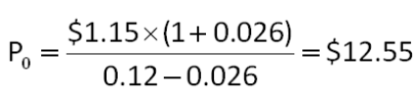

AACSB: Analytic
Difficulty: Basic
Learning Objective: 8-1
Section: 8.1
Topic: Stock price
58. Sessler Manufacturers made two announcements concerning its common stock today. First, the company announced that the next annual dividend will be $1.75 a share. Secondly, all dividends after that will decrease by 1.5 percent annually. What is the maximum amount you should pay to purchase a share of this stock today if you require a 14 percent rate of return?
A. $11.29
B. $12.64
C. $13.27
D. $14.00
E. $14.21
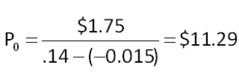

AACSB: Analytic
Difficulty: Basic
Learning Objective: 8-1
Section: 8.1
Topic: Negative growth
59. How much are you willing to pay for one share of Jumbo Trout stock if the company just paid a $0.70 annual dividend, the dividends increase by 1.6 percent annually, and you require a 10 percent rate of return?
A. $8.29
B. $8.33
C. $8.47
D. $8.53
E. $8.59
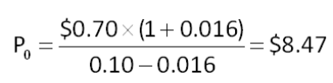

AACSB: Analytic
Difficulty: Basic
Learning Objective: 8-1
Section: 8.1
Topic: Stock price
60. Free Motion Enterprises paid a $2.20 per share annual dividend last week. Dividends are expected to increase by 3.75 percent annually. What is one share of this stock worth to you today if your required rate of return is 15 percent?
A. $19.06
B. $19.30
C. $19.56
D. $20.29
E. $20.59
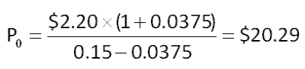

AACSB: Analytic
Difficulty: Basic
Learning Objective: 8-1
Section: 8.1
Topic: Stock price
61. Upper Crust Bakers just paid an annual dividend of $2.80 a share and is expected to increase that amount by 4 percent per year. If you are planning to buy 1,000 shares of this stock next year, how much should you expect to pay per share if the market rate of return for this type of security is 11.50 percent at the time of your purchase?
A. $37.33
B. $38.16
C. $38.83
D. $40.38
E. $42.00
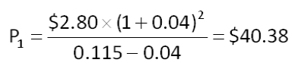

AACSB: Analytic
Difficulty: Basic
Learning Objective: 8-1
Section: 8.1
Topic: Stock price
62. The common stock of Textile Mills pays an annual dividend of $1.65 a share. The company has promised to maintain a constant dividend even though economic times are tough. How much are you willing to pay for one share of this stock if you want to earn a 12 percent annual return?
A. $13.75
B. $14.01
C. $14.56
D. $14.79
E. $15.23
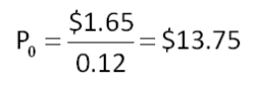

AACSB: Analytic
Difficulty: Basic
Learning Objective: 8-1
Section: 8.1
Topic: Constant dividend
63. Show Boat Dinner Theatres has paid annual dividends of $0.32, $0.48, and $0.60 a share over the past three years, respectively. The company now predicts that it will maintain a constant dividend since its business has leveled off and sales are expected to remain relatively flat. Given the lack of future growth, you will only buy this stock if you can earn at least a 16 percent rate of return. What is the maximum amount you are willing to pay for one share of this stock today?
A. $3.43
B. $3.75
C. $4.43
D. $4.69
E. $4.82
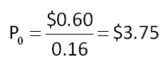

AACSB: Analytic
Difficulty: Basic
Learning Objective: 8-1
Section: 8.1
Topic: Constant dividend
64. The common stock of Auto Deliveries sells for $28.16 a share. The stock is expected to pay $1.35 per share next year when the annual dividend is distributed. The firm has established a pattern of increasing its dividends by 3 percent annually and expects to continue doing so. What is the market rate of return on this stock?
A. 7.42 percent
B. 7.79 percent
C. 19.67 percent
D. 20.14 percent
E. 20.86 percent
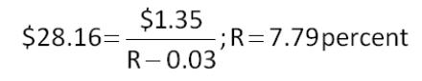

AACSB: Analytic
Difficulty: Basic
Learning Objective: 8-1
Section: 8.1
Topic: Required return
65. The current dividend yield on Clayton's Metals common stock is 2.5 percent. The company just paid a $1.48 annual dividend and announced plans to pay $1.54 next year. The dividend growth rate is expected to remain constant at the current level. What is the required rate of return on this stock?
A. 6.55 percent
B. 6.82 percent
C. 7.08 percent
D. 7.39 percent
E. 7.75 percent
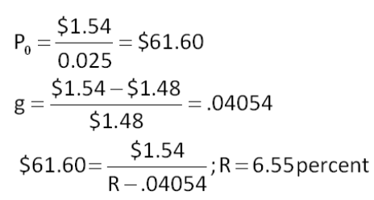

AACSB: Analytic
Difficulty: Intermediate
Learning Objective: 8-1
Section: 8.1
Topic: Required return
66. Northern Gas recently paid a $2.80 annual dividend on its common stock. This dividend increases at an average rate of 3.8 percent per year. The stock is currently selling for $26.91 a share. What is the market rate of return?
A. 13.88 percent
B. 14.03 percent
C. 14.21 percent
D. 14.37 percent
E. 14.60 percent
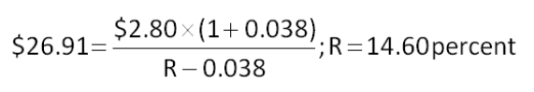

AACSB: Analytic
Difficulty: Basic
Learning Objective: 8-1
Section: 8.1
Topic: Required return
67. Denver Shoppes will pay an annual dividend of $1.46 a share next year with future dividends increasing by 4.2 percent annually. What is the market rate of return if the stock is currently selling for $38.90 a share?
A. 6.55 percent
B. 7.13 percent
C. 7.46 percent
D. 7.95 percent
E. 8.29 percent
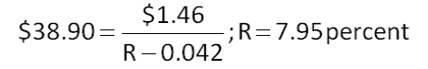

AACSB: Analytic
Difficulty: Basic
Learning Objective: 8-1
Section: 8.1
Topic: Required return
68. Great Lakes Health Care common stock offers an expected total return of 9.2 percent. The last annual dividend was $2.10 a share. Dividends increase at a constant 2.6 percent per year. What is the dividend yield?
A. 3.75 percent
B. 4.20 percent
C. 4.55 percent
D. 5.25 percent
E. 6.60 percent
Dividend yield = 0.092 - 0.026 = 6.6 percent

AACSB: Analytic
Difficulty: Basic
Learning Objective: 8-1
Section: 8.1
Topic: Dividend yield
69. Electronics, Inc. common stock returned a nifty 22.68 percent rate of return last year. The dividend amount was $0.25 a share which equated to a dividend yield of 0.84 percent. What was the rate of price appreciation for the year?
A. 21.84 percent
B. 22.38 percent
C. 22.60 percent
D. 22.87 percent
E. 23.52 percent
g = 0.2268 - 0.0084 = 21.84 percent

AACSB: Analytic
Difficulty: Basic
Learning Objective: 8-1
Section: 8.1
Topic: Growth rate
70. Roy's Welding Supplies common stock sells for $38 a share and pays an annual dividend that increases by 3 percent annually. The market rate of return on this stock is 8.20 percent. What is the amount of the last dividend paid?
A. $1.80
B. $1.86
C. $1.92
D. $1.98
E. $2.10
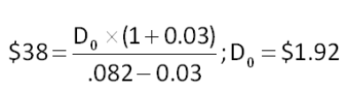

AACSB: Analytic
Difficulty: Basic
Learning Objective: 8-1
Section: 8.1
Topic: Dividend amount
71. Douglass Gardens pays an annual dividend that is expected to increase by 4.1 percent per year. The stock commands a market rate of return of 12.6 percent and sells for $24.90 a share. What is the expected amount of the next dividend?
A. $2.03
B. $2.12
C. $3.17
D. $2.20
E. $2.28
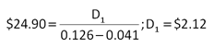

AACSB: Analytic
Difficulty: Basic
Learning Objective: 8-1
Section: 8.1
Topic: Dividend amount
72. Atlas Mines has adopted a policy of increasing the annual dividend on its common stock at a constant rate of 2.75 percent annually. The firm just paid an annual dividend of $1.67. What will the dividend be six years from now?
A. $1.88
B. $1.92
C. $1.97
D. $2.02
E. $2.05
D₆ = $1.67 × (1.0275)⁶ = $1.97

AACSB: Analytic
Difficulty: Basic
Learning Objective: 8-1
Section: 8.1
Topic: Dividend amount
73. A stock pays a constant annual dividend and sells for $56.10 a share. If the market rate of return on this stock is 15.85 percent, what is the amount of the next annual dividend?
A. $7.67
B. $7.94
C. $8.21
D. $8.89
E. $10.30
D₀ = 0.1585 × $56.10 = $8.89

AACSB: Analytic
Difficulty: Basic
Learning Objective: 8-1
Section: 8.1
Topic: Dividend amount
74. You want to purchase some shares of Green World stock but need a 15 percent rate of return to compensate for the perceived risk of such ownership. What is the maximum you are willing to spend per share to buy this stock if the company pays a constant $0.90 annual dividend per share?
A. $5.40
B. $6.00
C. $6.90
D. $7.20
E. $7.80
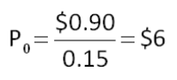

AACSB: Analytic
Difficulty: Basic
Learning Objective: 8-1
Section: 8.1
Topic: Constant dividend
75. Home Canning Products common stock sells for $44.96 a share and has a market rate of return of 12.8 percent. The company just paid an annual dividend of $1.04 per share. What is the dividend growth rate?
A. 8.29 percent
B. 8.45 percent
C. 9.23 percent
D. 9.67 percent
E. 10.25 percent
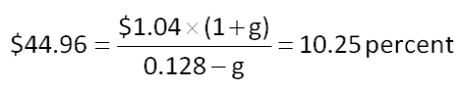

AACSB: Analytic
Difficulty: Basic
Learning Objective: 8-1
Section: 8.1
Topic: Dividend growth rate
76. Winter Time Adventures is going to pay an annual dividend of $2.86 a share on its common stock next year. This year, the company paid a dividend of $2.75 a share. The company adheres to a constant rate of growth dividend policy. What will one share of this common stock be worth five years from now if the applicable discount rate is 11.7 percent?
A. $43.45
B. $43.87
C. $44.15
D. $45.19
E. $47.00
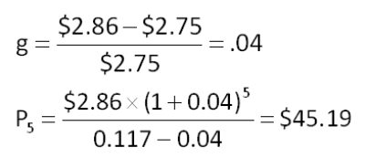

AACSB: Analytic
Difficulty: Intermediate
Learning Objective: 8-1
Section: 8.1
Topic: Future stock price
77. Hightower Pharmacy just paid a $3.10 annual dividend. The company has a policy of increasing the dividend by 3.8 percent annually. You would like to purchase 100 shares of stock in this firm but realize that you will not have the funds to do so for another four years. If you require a 16 percent rate of return, how much will you be willing to pay per share for the 100 shares when you can afford to make this investment?
A. $29.50
B. $30.62
C. $31.12
D. $31.78
E. $32.47
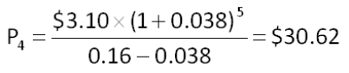

AACSB: Analytic
Difficulty: Basic
Learning Objective: 8-1
Section: 8.1
Topic: Future stock price
78. National Warehousing just announced it is increasing its annual dividend to $1.18 next year and establishing a policy whereby the dividend will increase by 3.25 percent annually thereafter. How much will one share of this stock be worth 8 years from now if the required rate of return is 9.5 percent?
A. $24.38
B. $25.68
C. $26.51
D. $27.02
E. $27.37
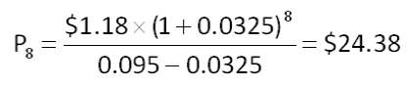

AACSB: Analytic
Difficulty: Basic
Learning Objective: 8-1
Section: 8.1
Topic: Future stock price
79. Shares of Hot Donuts common stock are currently selling for $32.35. The last annual dividend paid was $1.10 per share and the market rate of return is 10.7 percent. At what rate is the dividend growing?
A. 7.06 percent
B. 8.67 percent
C. 10.42 percent
D. 12.60 percent
E. 14.10 percent
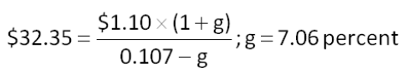

AACSB: Analytic
Difficulty: Basic
Learning Objective: 8-1
Section: 8.1
Topic: Dividend growth rate
80. Combined Communications is a new firm in a rapidly growing industry. The company is planning on increasing its annual dividend by 15 percent a year for the next 4 years and then decreasing the growth rate to 3.5 percent per year. The company just paid its annual dividend in the amount of $0.20 per share. What is the current value of one share of this stock if the required rate of return is 15.5 percent?
A. $1.82
B. $2.04
C. $2.49
D. $2.71
E. $3.05
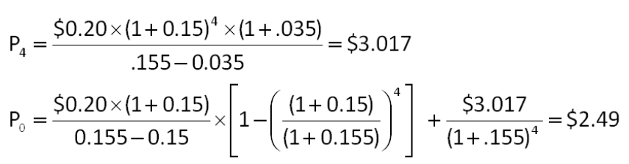

AACSB: Analytic
Difficulty: Intermediate
Learning Objective: 8-1
Section: 8.1
Topic: Two-stage growth
81. KL Airlines paid an annual dividend of $1.42 a share last month. The company is planning on paying $1.50, $1.75, and $1.80 a share over the next 3 years, respectively. After that, the dividend will be constant at $2 per share per year. What is the market price of this stock if the market rate of return is 10.5 percent?
A. $15.98
B. $16.07
C. $18.24
D. $21.16
E. $24.10
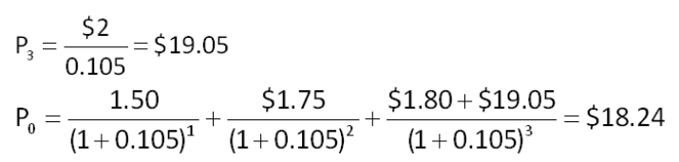

AACSB: Analytic
Difficulty: Intermediate
Learning Objective: 8-1
Section: 8.1
Topic: Nonconstant dividends
82. Renew It, Inc., is preparing to pay its first dividend. It is going to pay $0.45, $0.60, and $1 a share over the next three years, respectively. After that, the company has stated that the annual dividend will be $1.25 per share indefinitely. What is this stock worth to you per share if you demand a 10.8 percent rate of return on stocks of this type?
A. $6.67
B. $8.21
C. $10.14
D. $11.47
E. $12.03
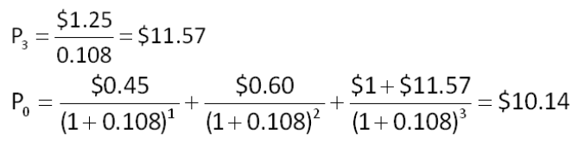

AACSB: Analytic
Difficulty: Intermediate
Learning Objective: 8-1
Section: 8.1
Topic: Nonconstant dividends
83. Diets For You announced today that it will begin paying annual dividends next year. The first dividend will be $0.12 a share. The following dividends will be $0.15, $0.20, $0.50, and $0.60 a share annually for the following 4 years, respectively. After that, dividends are projected to increase by 4 percent per year. How much are you willing to pay to buy one share of this stock today if your desired rate of return is 8.5 percent?
A. $9.67
B. $9.94
C. $10.38
D. $10.50
E. $10.86
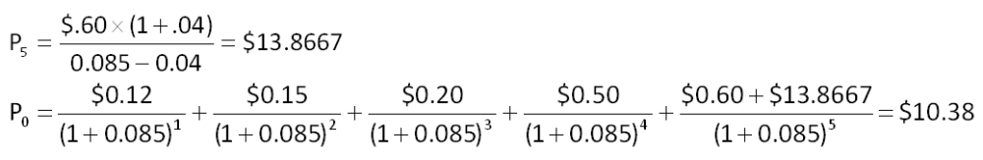

AACSB: Analytic
Difficulty: Intermediate
Learning Objective: 8-1
Section: 8.1
Topic: Nonconstant dividends
84. Crystal Glass recently paid $3.60 as an annual dividend. Future dividends are projected at $3.80, $4.10, and $4.25 over the next 3 years, respectively. Beginning 4 years from now, the dividend is expected to increase by 3.25 percent annually. What is one share of this stock worth to you if you require a 12.5 percent rate of return on similar investments?
A. $42.92
B. $43.40
C. $45.12
D. $45.88
E. $46.50
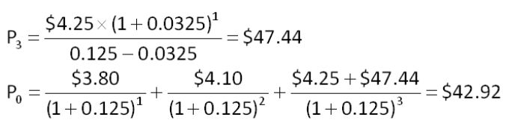

AACSB: Analytic
Difficulty: Intermediate
Learning Objective: 8-1
Section: 8.1
Topic: Nonconstant dividends
85. Langley Enterprises pays a constant dividend of $0.60 a share. The company announced today that it will continue to pay the dividend for another 2 years after which time all dividends will cease. What is one share of this stock worth today if the required rate of return is 16.5 percent?
A. $0.92
B. $0.96
C. $1.04
D. $1.09
E. $1.20
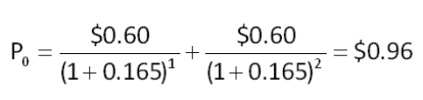

AACSB: Analytic
Difficulty: Basic
Learning Objective: 8-1
Section: 8.1
Topic: Nonconstant dividends
86. Yesteryear Productions pays no dividend at the present time. The company plans to start paying an annual dividend in the amount of $0.40 a share for two years commencing four years from today. After that time, the company plans on paying a constant $0.75 a share annual dividend indefinitely. How much are you willing to pay to buy a share of this stock today if your required return is 11.6 percent?
A. $3.78
B. $4.22
C. $4.37
D. $4.71
E. $4.98
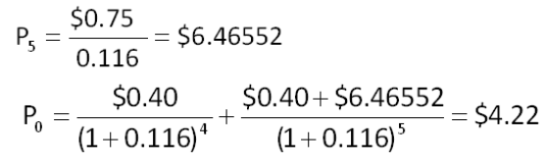

AACSB: Analytic
Difficulty: Intermediate
Learning Objective: 8-1
Section: 8.1
Topic: Nonconstant dividends
87. Sweatshirts Unlimited is downsizing. The company paid a $2.80 annual dividend last year. The company has announced plans to lower the dividend by 25 percent each year. Once the dividend amount becomes zero, the company will cease all dividends and go out of business. You have a required rate of return of 15.5 percent on this particular stock given the company's situation. What are your shares in this firm worth today on a per share basis?
A. $5.19
B. $6.91
C. $8.68
D. $19.29
E. $22.11
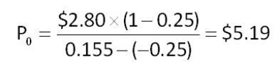

AACSB: Analytic
Difficulty: Basic
Learning Objective: 8-1
Section: 8.1
Topic: Negative growth
88. Dexter Metals, paid its first annual dividend yesterday in the amount of $0.18 a share. The company plans to double each annual dividend payment for the next 3 years. After that time, it plans to pay $1.25 a share for 2 years than then pay a constant dividend of $1.60 per share indefinitely. What is one share of this stock worth today if the market rate of return on similar securities is 10.24 percent?
A. $12.32
B. $12.77
C. $13.20
D. $14.26
E. $14.79
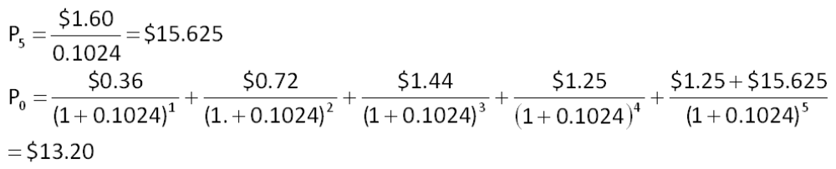

AACSB: Analytic
Difficulty: Intermediate
Learning Objective: 8-1
Section: 8.1
Topic: Nonconstant growth
89. Marshall Arts Studios just paid an annual dividend of $1.36 a share. The firm plans to pay annual dividends of $1.40, $1.46, and $1.58 over the next 3 years, respectively. After that time, the dividends will be held constant at $1.60 per share. What is this stock worth today at a 9 percent discount rate?
A. $14.08
B. $14.30
C. $16.67
D. $16.79
E. $17.46
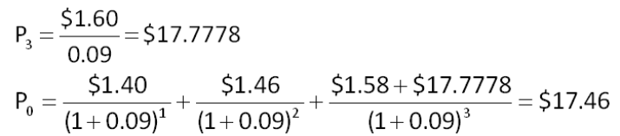

AACSB: Analytic
Difficulty: Intermediate
Learning Objective: 8-1
Section: 8.1
Topic: Nonconstant dividends
90. Home Care Providers is paying an annual dividend of $1.10 every other year. The last dividend was paid two years ago. The firm will continue this policy until 3 more dividend payments have been paid. One year after the last dividend normal payment, the company plans to pay a final liquidating dividend of $40 per share. What is the current market value of this stock if the required return is 17 percent?
A. $18.92
B. $20.74
C. $23.16
D. $24.14
E. $24.53
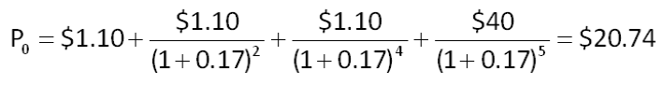

AACSB: Analytic
Difficulty: Intermediate
Learning Objective: 8-1
Section: 8.1
Topic: Nonconstant dividends
91. Last year, Hansen Delivery paid an annual dividend of $3.20 per share. The company has been reducing the dividends by 10 percent annually. How much are you willing to pay to purchase stock in this company if your required rate of return is 11.5 percent?
A. $1.92
B. $7.87
C. $13.40
D. $21.16
E. $24.08
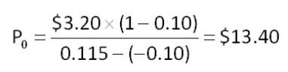

AACSB: Analytic
Difficulty: Basic
Learning Objective: 8-1
Section: 8.1
Topic: Negative growth
92. Beatrice Markets is expecting a period of intense growth and has decided to retain more of its earnings to help finance that growth. As a result, it is going to reduce its annual dividend by 30 percent a year for the next 2 years. After that, it will maintain a constant dividend of $2.50 a share. Last year, the company paid $3.60 as the annual dividend per share. What is the market value of this stock if the required rate of return is 14.5 percent?
A. $14.63
B. $16.70
C. $18.08
D. $19.61
E. $21.23
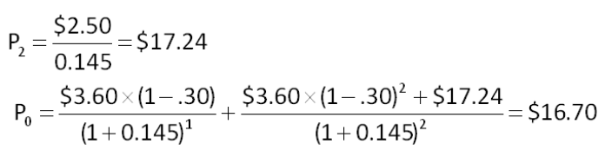

AACSB: Analytic
Difficulty: Intermediate
Learning Objective: 8-1
Section: 8.1
Topic: Nonconstant dividends
93. Bonnie's Ice Cream is expecting its ice cream sales to decline due to the increased interest in healthy eating. Thus, the company has announced that it will be reducing its annual dividend by 2 percent a year for the next five years. After that, it will maintain a constant dividend of $2 a share. Last year, the company paid $2.20 per share. What is this stock worth to you if you require a 9.5 percent rate of return?
A. $16.21
B. $17.48
C. $18.64
D. $19.09
E. $21.36
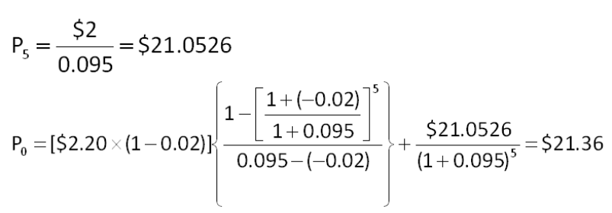

AACSB: Analytic
Difficulty: Intermediate
Learning Objective: 8-1
Section: 8.1
Topic: Nonconstant dividends
94. J&J Foods wants to issue some 7 percent preferred stock that has a stated liquidating value of $100 a share. The company has determined that stocks with similar characteristics provide a 12.8 percent rate of return. What should the offer price be?
A. $37.26
B. $41.38
C. $48.20
D. $54.69
E. $62.60
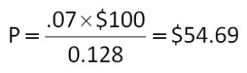

AACSB: Analytic
Difficulty: Basic
Learning Objective: 8-1
Section: 8.1
Topic: Preferred stock
95. The preferred stock of Rail Lines, Inc., pays an annual dividend of $7.50 and sells for $59.70 a share. What is the rate of return on this security?
A. 10.38 percent
B. 11.63 percent
C. 12.56 percent
D. 12.72 percent
E. 12.84 percent
R = $7.50/$59.70 = 12.56 percent

AACSB: Analytic
Difficulty: Basic
Learning Objective: 8-1
Section: 8.1
Topic: Preferred stock
96. Marie owns shares of Deltona Productions preferred stock which she says provides her with a constant 14.3 percent rate of return. The stock is currently priced at $45.45 a share. What is the amount of the dividend per share?
A. $6.00
B. $6.25
C. $6.50
D. $6.60
E. $7.00
D = 0.143 × $45.45 = $6.50

AACSB: Analytic
Difficulty: Basic
Learning Objective: 8-1
Section: 8.1
Topic: Preferred stock
97. Zylo, Inc. preferred stock pays a $7.50 annual dividend. What is the maximum price you are willing to pay for one share of this stock today if your required return is 9.75 percent?
A. $32.26
B. $35.48
C. $72.68
D. $76.92
E. $79.81
P₀ = $7.50/0.0975 = $76.92

AACSB: Analytic
Difficulty: Basic
Learning Objective: 8-1
Section: 8.1
Topic: Preferred stock

Essay Questions
98. What are the primary differences and similarities between NASDAQ and the NYSE?
The NYSE has a physical trading floor in New York City, is primarily a broker market, relies on specialists for liquidity under a single market maker system, utilizes the SuperDOT system, and has stricter listing requirements. NASDAQ is an electronic network of dealers and utilizes a multiple market maker system. NASDAQ is open to ECNs but the NYSE is not. NASDAQ has no physical trading floor.
Feedback: Refer to section 8.3

AACSB: Reflective thinking
Difficulty: Intermediate
Learning Objective: 8-3
Section: 8.3
Topic: NYSE and NASDAQ
99. Using the dividend growth model, explain why a firm would be hesitant to reduce the growth rate of its dividends.
The dividend growth model states that P_{t} = D_{t+1}/(R - g). A reduction in the growth rate will reduce both D_{t+1} and g. Lowering the value of these variables will effectively lower the value of the firm's stock, which is something firms are hesitant to do.
Feedback: Refer to section 8.1

AACSB: Reflective thinking
Difficulty: Intermediate
Learning Objective: 8-1
Section: 8.1
Topic: Dividend growth model
100. Kelley wants to purchase shares in Classic Kars, Inc., but is torn between buying shares of common stock or shares of preferred stock. What should he consider before determining the type of share he should purchase?
Kelley needs to identify the reasons he wishes to purchase this stock. If he is looking for a steady stream of income and preferential treatment should the company go bankrupt, then he should purchase preferred stock. On the other hand, if he believes the company has a bright financial future and wishes to share in that success, then he should buy common stock and enjoy the benefits of residual ownership associated with high profitability. In addition, if he wishes to have a voice in company matters, he should purchase common stock to ensure that he will have voting rights.
Feedback: Refer to section 8.2

AACSB: Reflective thinking
Difficulty: Intermediate
Learning Objective: 8-1
Section: 8.2
Topic: Common and preferred stock
101. Explain why small shareholders should prefer cumulative voting over straight voting.
With straight voting, a shareholder must control a majority (50 percent plus one) of the outstanding shares of stock to gain access to a seat on the board of directors. With cumulative voting, a shareholder can control one seat on the board by controlling a lesser number of shares. The number of shares needed to obtain one seat under cumulative voting is computed as [1/(N+1)] percent + 1 of the outstanding shares, where N is the number of open seats. If for example, three seats are open, a shareholder only needs to control 25 percent, or 1/4th, of the outstanding shares plus one additional share to guarantee election to the board. Having a seat on the board allows a shareholder to have some control over the direction and management of a firm.
Feedback: Refer to section 8.2

AACSB: Reflective thinking
Difficulty: Intermediate
Learning Objective: 8-2
Section: 8.2
Topic: Voting
102. Ted, a wealthy individual, plans to purchase 30 percent of a firm's Class A shares of outstanding stock. He believes that such a purchase will allow him to control the firm by electing his candidates to the board over time as current board member's terms expire. The firm has a cumulative voting process. What factors should Ted be considering and why to ensure he can gain the control he desires?
Since the stock Ted plans to purchase is denoted as Class A, Ted should determine if the firm has other classes of stock outstanding and if so, how that will affect the outcome of any election. Generally speaking, different classes of stock are assigned different voting rights. It could be that shareholders of another class of stock effectively control the firm. He should also be concerned about the number of positions that are elected at one time as he needs to ensure that his 30 percent ownership is sufficient to control at least one seat at each election.
Feedback: Refer to section 8.2

AACSB: Reflective thinking
Difficulty: Intermediate
Learning Objective: 8-2
Section: 8.2
Topic: Stock classes
103. Explain the primary change that occurred in the structure of the NYSE in 2006 and how that change affected the exchange members.
In 2006, the NYSE became a publicly owned corporation called NYSE Group, Inc. Exchange members no longer purchase, or own, seats on the exchange nor do they own the firm based solely on their membership. Members now purchase trading licenses which grant their owners the right to transact trades on the floor of the exchange. Ownership of the NYSE now lies in the hands of the NYSE Group, Inc.'s, shareholders.
Feedback: Refer to section 8.3

AACSB: Reflective thinking
Difficulty: Basic
Learning Objective: 8-3
Section: 8.3
Topic: NYSE structure

Multiple Choice Questions
104. Jefferson Mills just paid a dividend of $1.56 per share on its stock. The dividends are expected to grow at a constant rate of 8 percent per year, indefinitely. What will the price of this stock be in 7 years if investors require a 15 percent rate of return?
A. $28.18
B. $32.04
C. $37.46
D. $41.25
E. $43.33
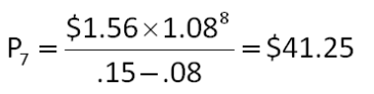

AACSB: Analytic
Difficulty: Basic
EOC #: 8-1
Learning Objective: 8-1
Section: 8.1
Topic: Stock price
105. The next dividend payment by Hillside Markets will be $2.35 per share. The dividends are anticipated to maintain a 4.5 percent growth rate forever. The stock currently sells for $70 per share. What is the dividend yield?
A. 3.20 percent
B. 3.36 percent
C. 3.54 percent
D. 4.50 percent
E. 4.81 percent
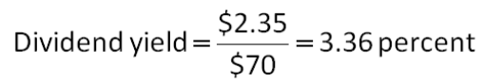

AACSB: Analytic
Difficulty: Basic
EOC #: 8-3
Learning Objective: 8-1
Section: 8.1
Topic: Dividend yield
106. The Stiller Corporation will pay a $3.80 per share dividend next year. The company pledges to increase its dividend by 2.4 percent indefinitely. How much are you willing to pay to purchase this company's stock today if you require a 6.9 percent return on your investment?
A. $55.07
B. $63.09
C. $72.22
D. $78.47
E. $84.44
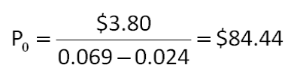

AACSB: Analytic
Difficulty: Basic
EOC #: 8-4
Learning Objective: 8-1
Section: 8.1
Topic: Stock price
107. Suppose you know a company's stock currently sells for $90 per share and the required return on the stock is 10 percent. You also know that the total return on the stock is evenly divided between a capital gains yield and a dividend yield. What is the current dividend if it's the company's policy to always maintain a constant growth rate in its dividends?
A. $4.18
B. $4.29
C. $4.37
D. $4.50
E. $4.64
Dividend yield = 0.10/2 = 0.05
D₁ = 0.05 × $90 = $4.50
D₀ = $4.50/1.05 = $4.29

AACSB: Analytic
Difficulty: Basic
EOC #: 8-6
Learning Objective: 8-1
Section: 8.1
Topic: Current dividend
108. Whistle Stop Trains pays a constant $16 dividend on its stock. The company will maintain this dividend for the next 14 years and will then cease paying dividends forever. What is the current price per share if the required return on this stock is 15 percent?
A. $77.78
B. $82.48
C. $91.59
D. $106.67
E. $112.00
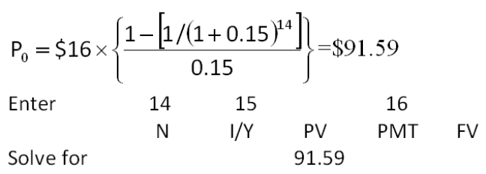

AACSB: Analytic
Difficulty: Basic
EOC #: 8-7
Learning Objective: 8-1
Section: 8.1
Topic: Stock price
109. Morristown Industries has an issue of preferred stock outstanding that pays a $13.25 dividend every year in perpetuity. What is the required return if this issue currently sells for $80 per share?
A. 16.56 percent
B. 16.72 percent
C. 16.80 percent
D. 16.86 percent
E. 16.95 percent
R = $13.25/$80 = 16.56 percent

AACSB: Analytic
Difficulty: Basic
EOC #: 8-8
Learning Objective: 8-1
Section: 8.1
Topic: Required return
110. The Farmer's Market just paid an annual dividend of $5 on its stock. The growth rate in dividends is expected to be a constant 5 percent per year indefinitely. Investors require a 13 percent return on the stock for the first 3 years, a 9 percent return for the next 3 years, a 7 percent return thereafter. What is the current price per share?
A. $212.40
B. $220.54
C. $223.09
D. $226.84
E. $227.50
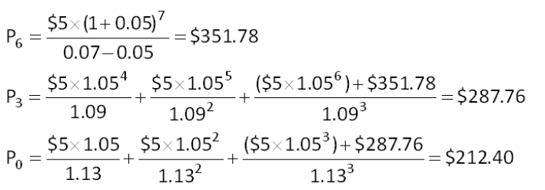

AACSB: Analytic
Difficulty: Intermediate
EOC #: 8-10
Learning Objective: 8-1
Section: 8.1
Topic: Stock price
111. Springboro Tech is a young start-up company. No dividends will be paid on the stock over the next 15 years, because the firm needs to plow back its earnings to fuel growth. The company will pay a $12 per share dividend in 16 years and will increase the dividend by 3 percent per year thereafter. What is the current share price if the required return on this stock is 8 percent?
A. $75.66
B. $88.19
C. $120.00
D. $164.59
E. $240.00
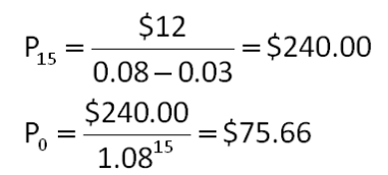

AACSB: Analytic
Difficulty: Intermediate
EOC #: 8-11
Learning Objective: 8-1
Section: 8.1
Topic: Stock price
112. Galloway, Inc. has an odd dividend policy. The company has just paid a dividend of $7 per share and has announced that it will increase the dividend by $2 per share for each of the next 5 years, and then never pay another dividend. How much are you willing to pay per share today to buy this stock if you require a 15 percent return?
A. $27.08
B. $34.15
C. $41.72
D. $42.60
E. $43.33
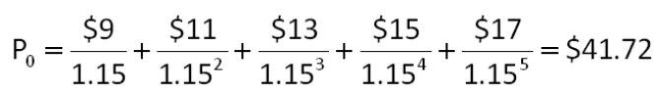

AACSB: Analytic
Difficulty: Intermediate
EOC #: 8-12
Learning Objective: 8-1
Section: 8.1
Topic: Stock price
113. Jen's Fashions is growing quickly. Dividends are expected to grow at a 22 percent rate for the next 3 years, with the growth rate falling off to a constant 8 percent thereafter. The required return is 12 percent and the company just paid a $3.80 annual dividend. What is the current share price?
A. $128.96
B. $131.11
C. $146.17
D. $148.87
E. $152.20
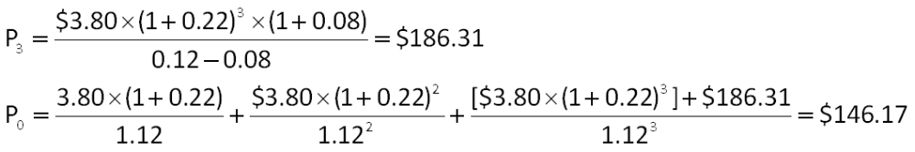

AACSB: Analytic
Difficulty: Intermediate
EOC #: 8-14
Learning Objective: 8-1
Section: 8.1
Topic: Stock price
114. Hardwoods, Inc. is a mature manufacturing firm. The company just paid a $10 dividend, but management expects to reduce the payout by 9 percent each year, indefinitely. How much are you willing to pay today per share to buy this stock if you require a 15 percent rate of return?
A. $34.79
B. $37.92
C. $38.27
D. $41.33
E. $42.09
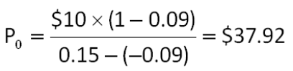

AACSB: Analytic
Difficulty: Intermediate
Learning Objective: 8-1
Section: 8.1
Topic: Stock price
115. Bechtel Machinery stock currently sells for $50 per share. The market requires a 15 percent return on the firm's stock. The company maintains a constant 8 percent growth rate in dividends. What was the most recent annual dividend per share paid on this stock?
A. $3.00
B. $3.24
C. $3.50
D. $3.67
E. $3.91
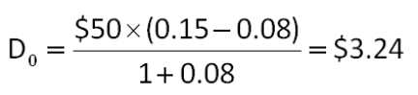

AACSB: Analytic
Difficulty: Intermediate
EOC #: 8-17
Learning Objective: 8-1
Section: 8.1
Topic: Current dividend
116. Southern Utilities just issued some new preferred stock. The issue will pay a $19 annual dividend in perpetuity beginning 9 years from now. What is one share of this stock worth today if the market requires a 7 percent return on this investment?
A. $157.97
B. $164.16
C. $189.08
D. $241.41
E. $271.43
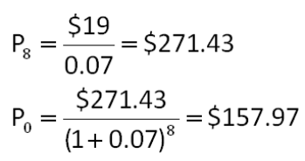

AACSB: Analytic
Difficulty: Intermediate
EOC #: 8-18
Learning Objective: 8-1
Section: 8.1
Topic: Stock price
117. Big Falls Tours just paid a dividend of $1.55 per share. The dividends are expected to grow at 30 percent for the next 8 years and then level off to a 7 percent growth rate indefinitely. What is the price of this stock today given a required return of 15 percent?
A. $67.54
B. $69.90
C. $72.47
D. $77.67
E. $78.19
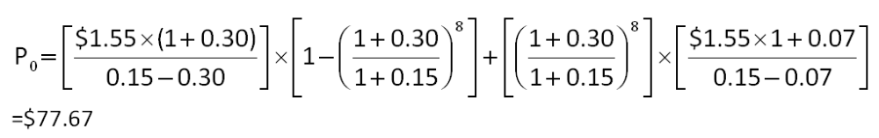

AACSB: Analytic
Difficulty: Intermediate
EOC #: 8-20
Learning Objective: 8-1
Section: 8.1
Topic: Stock price
118. Harvey County Choppers, Inc. is experiencing rapid growth. The company expects dividends to grow at 25 percent per year for the next 7 years before leveling off to 7 percent into perpetuity. The required return on the stock is 12 percent. What is the current stock price if the annual dividend share that was just paid was $1.05?
A. $60.15
B. $64.36
C. $67.37
D. $72.11
E. $75.19
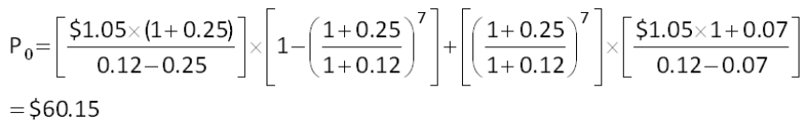

AACSB: Analytic
Difficulty: Intermediate
EOC #: 8-21
Learning Objective: 8-1
Section: 8.1
Topic: Stock price
119. Westover Winds just paid a dividend of $2.50 per share. The company will increase its dividend by 8 percent next year and will then reduce its dividend growth rate by 2 percentage points per year until it reaches the industry average of 2 percent dividend growth, after which the company will keep a constant growth rate forever. What is the price of this stock today given a required return of 12 percent?
A. $28.42
B. $28.99
C. $31.83
D. $32.06
E. $32.47
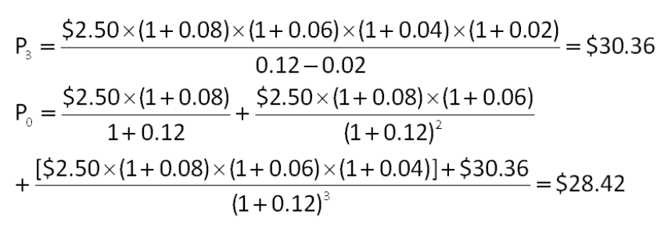

AACSB: Analytic
Difficulty: Challenge
EOC #: 8-24
Learning Objective: 8-1
Section: 8.1
Topic: Stock price

